**Name: Amit Kunwar**

**Level 4 Cyber security and forensic science**

**UID:** **23085146**

**Task 1**

1. Download Git from here <https://git-scm.com/> (Version 2.26.2)

Done✅

1. Install Git (Installation Guide: <https://www.youtube.com/watch?v=SWYqp7iY_Tc>)

Done✅

1. Create a Folder in Desktop with name “L3” and Right Click on folder L3 and **Select Git Bash Here**. You will see this screen

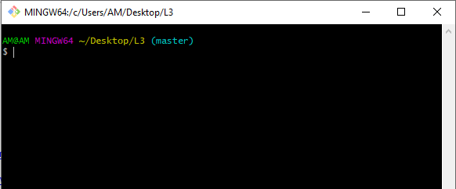

1. Check git version

* *git –version*



1. Now add files with this Command:

* *touch index.html*
* *touch about.html*
* *touch resources.txt*



1. Check your Folder, you will see these files

**

1. Open your file index.html in notepad or notepad++. Add these lines of code & save

*<html>*

*<head>*

*<title> My Title </title>*

*</head>*

*<body>*

*My First Page*

*</body>*

*</html>*

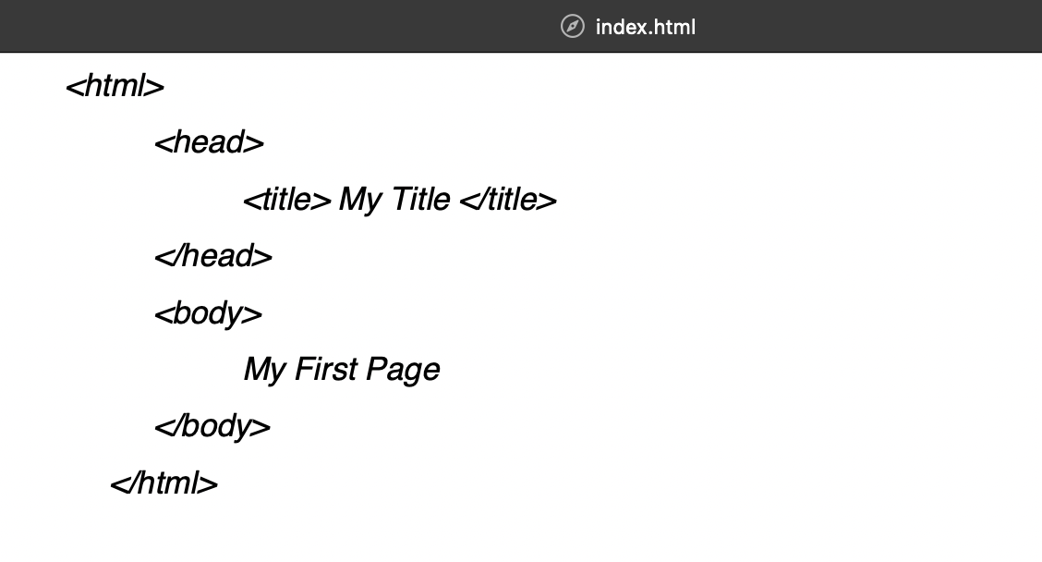

1. Open resources.txt and Write your name and Save this file

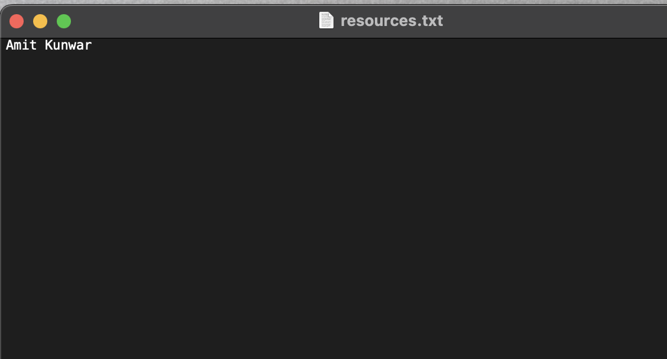

1. Initialize a Git repository/working directory
   * *git init*

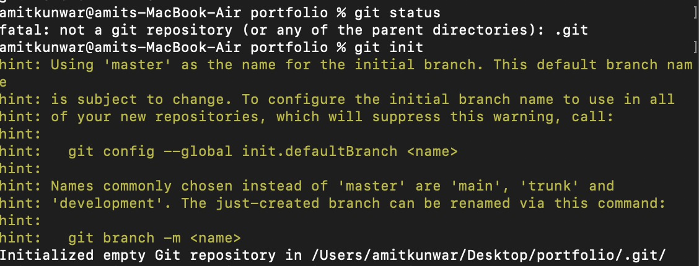

* + Check your Folder, you will see .git folder. And within this folder you will find Git Related Folders and files.

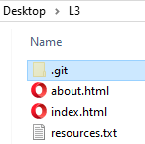

1. Configure user name and email
   * git config --global user.name ‘Your Name’
   * git config --global user.email ‘youremail@gmail.com’

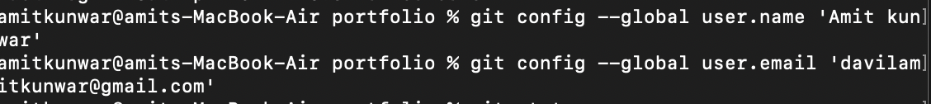

1. Check Status of Working directory
   * *git status*

1. Add file or files
   * *git add index.html / git add .*
   * *git add .*

**

1. Check Status of Working directory
   * *git status*

1. Commit chages in your working directory
   * *git commit*
   * *git commit –m “Some git commit message”*

1. After all commit, Check Status of Working directory (This will show you message like nothing to commit, working tree clean)
   * *git status*

**

1. Make changes to resources.txt. Add few names of your friends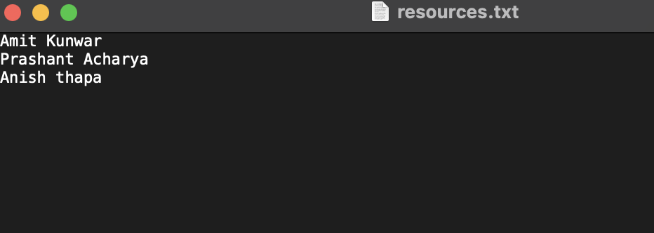
2. Check with git status, it will show (changes not staged for commit)
   * *git status*

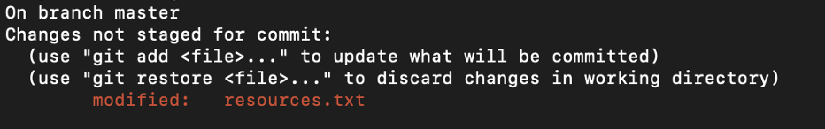

1. Add file or files
   * *git add .*

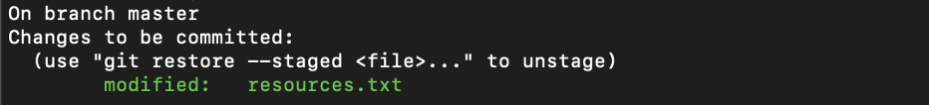

1. Commit changes in your working directory with commit message
   * *git commit -m ‘Changed resouces.txt’*

**

1. Check with git status, it will show (changes not staged for commit)
   * *git status*

